5. User Interface & User Experience Design
5.1. Screen Diagram:
Screen diagram:
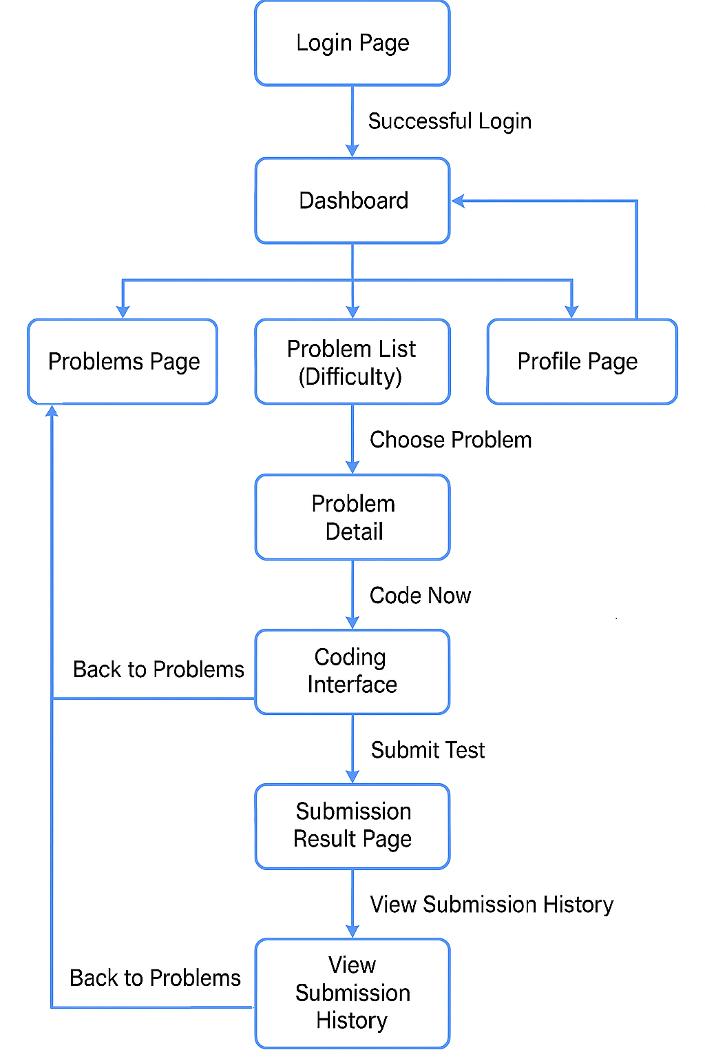

List of screens:
Seq | Screen Name | Description
1 | Login Page | Entry page for user authentication via email/password or social login
2 | Dashboard | Displays recent tests, progress bars, announcements, and user statistics
3 | Problems Page | Shows all categories of problems and supports search + sorting
4 | Problem List / Category Detail | Shows problem lists for selected category sorted by difficulty
5 | Problem Detail | Shows learning objectives, examples, constraints, and “Code Now”
6 | Coding Interface | Editor, console, language selector, run/submit controls
7 | Submission Result | Displays execution/compile results and submission history

5.2. Screen Specifications:
5.2.1 Screen A - Login Page
Presentation format:
The login page features:
- A two-column layout:
  - Left: Motivational graphics
  - Right: Login card with rounded corners and soft-gradient background.
- Form Fields
  - Email input
  - Password input (with visibility toggle)
- Primary Button: Loin
- Secondary Link: “Forgot Password?”
- Sign Up Navigation
- Third-Party Login Options: Google, GitHub, Facebook
- Responsive UI with centered card on smaller screens.
Event handling:
Event | Description
Login button click | Validates user credentials → On success, redirects to Dashboard; on failure, displays error.
Password visibility toggle | Switches input type between password and text.
Sign Up link | Navigates to the registration page.
Forgot Password | Opens password recovery workflow.
Social login icons | Invokes OAuth sign-in process.

5.2.2 Screen B - Dashboard
Presentation format:
- Left Sidebar Menu: Home, Problems, Submission, Profile, Settings, Logout.
- Header: Search bar, notification icon, profile dropdown.
- Sections:
  - Recent Tests: Scrollable cards with problem name and completion percentage.
  - Progress Bar Section: Three difficulty progress metrics (Easy, Medium, Hard).
  - Upcoming Problem Update: Announcement card with date and call-to-action button.
  - User Stats: Number of tests written, performance %, passes, runtime errors, etc.
Event handling:
Event | Description
Select sidebar menu item | Navigates to the respective screen.
Problem card click | Open Problem Detail screen.
Progress bar hover | Tooltip shows additional progress statistics.
Review Now button | Opens details related to upcoming problem update.
User icon dropdown | Change profile settings or logout.

5.2.3 Screen C - Problems Page
Presentation format:
Features a grid layout displaying distinct problem categories:
- DSA, Implementation/Simulation, Debugging, System Design, OOP, SQL.
- Each category card includes:
  - Icon/image
  - Category title
  - Short description
- Search bar for filtering categories.
- Sort By control in the upper right corner.

Event handling:
Event | Description
Clicking a category card | Navigates to the Problem List, Difficulty View.
Typing in search bar | Filters categories dynamically.
Clicking Sort By dropdown | Opens sorting options (alphabetical, progress, date done).

5.2.4 Screen D - Sorting Popup
Presentation format:
A floating white popup with rounded borders that overlays the problem grid. Contains:
- Alphabetical Order
- Progress
- Date Done
Event handling:
Event | Description
Selecting sorting criteria | Reorders category or problem list accordingly.
Clicking outside popup | Closes popup.

5.2.5 Screen E - Problem List (Choosing a Problem)
Presentation format:
Shows a list of problems divided by difficulty tabs:
- Tabs: Easy, Medium, Hard (highlighted color bar).
- For each difficulty:
  - List of problem titles (clickable)
  - Consistent box layout with subtle borders
- Global elements:
  - Search bar
  - Sort By dropdown
Event handling:
Event | Description
Selecting difficulty tab | Refreshes visible problem list.
Clicking a problem | Open Problem Detail screen.
Search input | Filters problem names.
Sorting list | Re-arranges according to selected rules.

5.2.6 Screen F - Problem Detail Page
Presentation format:
- Top section:
  - Problem title
  - Acceptance rate, total attempts
  - Difficulty tag (color-coded: Easy = green, Medium = yellow, Hard = red)
  - Status tag (Solved / Unsolved)
- Learning Objectives: Bullet points describing expected skills.
- Problem Summary: Short explanation of the problem.
- Examples (Example 1, Example 2) in blue-bordered boxes.
- Constraints listing allowed ranges.
- “Code Now” button leading to the coding interface.
Event handling:
Event | Description
Click “Code Now” | Opens Coding Interface with problem preloaded.
Scroll interaction | Sticky sidebar remains visible to maintain navigation.

5.2.7 Screen G - Coding Interface
Presentation format:
This is the core practice environment consisting of:
- Problem Description Panel (top section)
- Programming Panel (bottom left):
  - Language dropdown (C++, Python, Java, etc.)
  - Code editor with line numbers & dark theme
- Console Panel (right side):
  - Sample test inputs
  - Custom input field
- Run Button (bottom left)
- Submit Test Button (bottom right)
- Timer icon on top right

Event handling:
Event | Description
Language selection | Reloads editor with boilerplate code for selected language.
Run button | Compiles locally and displays console output.
Submit button | Sends code to judge → redirects to Submission Result page.
Entering custom input | Overrides sample test and uses user-provided input.

5.2.8 Screen H - Submission Result Page
Presentation format:
Shows status after code submission:
- Result Panel (red for compile/runtime errors, green for success)
- Parsed error message with line number indicators
- Test execution details: runtime, memory usage
- Navigation:
  - Previous Test
  - Next Test
- Submission History Table:
  - Status
  - Language
  - Runtime
  - Memory

Event handling:
Event | Description
View History button | Expands complete submission list.
Prev/Next Test | Browse test cases executed.
Click submission row | Loads details of chosen submission.

